**JavaScript**

* **Compiler:** The source code is converted into machine code once and then gets executed.

**Compiler Pros:**

* + Suppose we have a loop that runs 40 times, we do not need to translate the same code again and again. The time it saves is huge.
  + The converted code will be more efficient cause we have more time for optimization.

**Compiler Cons:**

* + It takes a little bit more time to start up because it has to go through that compilation step at the beginning.
* **Interpreter:** Interpreters are quick. We don’t have to go through that whole compilation step before execution. It just starts translating the first line and then executes it.

**Interpreter Pros**

* + Fast start-up times are characteristic of interpreters. That’s why browsers used JavaScript interpreters in the beginning.

**Interpreter Cons**

* + When you’re running the same code more than once. For example, if you’re in a loop. Then you have to do the same translation over and over and over again.
  + The code will be less efficient than the compiler because we have less time for optimization.
* **JIT Compiler:** In short Just in time compiler is nothing but a combination of an interpreter and a compiler. To get rid of the interpreter’s inefficiency, “the interpreter keeps retranslating the same code every time it goes through the loop”. In the JIT compiler, we have a new component called a monitor (aka a profiler). That monitor watches the code as it runs and
  + Identify the hot or warm components of the code eg: repetitive code.
  + Transform those components into machine code during run time.
  + Optimize the generated machine code.
  + Hot swap the previous implementation of the code.
* **Babel:** A trans piler that can convert ES6 code to ES5 code.
* **Typescript:** Typescript is a superset of JavaScript that compiles down to JavaScript.
* **Ecma International:** An organization that creates standards for technologies.
* **ECMA-262:** This is a standard published by Ecma International. It contains the specification for a general-purpose scripting language.
* **Scripting Language:** While programming languages are compiled, scripting languages are mostly interpreted. Even though there are some scripting languages that are both compiled and interpreted, such as Python and Groovy.
* **ECMAScript:** The specification defined in ECMA-262 for creating a general-purpose scripting language.
* **ECMAScript 6:** It is the sixth edition of the ECMA-262 standard, and features major changes and improvements to the ECMAScript specification.
* **JavaScript engine:** A program or interpreter that understands and executes JavaScript code. JavaScript has many JS engines like V8, SpiderMonkey, Chakra etc. JS Engine is also **Synchronous**.
* **JavaScript:** A high-level, general purpose **scripting language** that conforms to the ECMAScript specification and is built into browsers that allows you to implement functionality on web pages/apps. JavaScript is also available in other programming environments, such as Node.
* **Memory Heap:** It’s where the JS Engine allocates memory for variables and Objects.
* **Call Stack:** Stores the variables and functions as code executes and keeps track of where the code is in execution.
* **Stack Overflow:** Too many functions called and stored on call-stack that exceed call stack size.
* **Memory Leak**: When we use all our available memory heap and fill it with data (variables, objects, etc.).

Memory leaks can happen 3 different ways:

1. Global variables: Using too many global variables can lead to memory leak.
2. Event Listeners: Using too many event-listeners
3. Set Intervals: Objects inside the set-intervals

* **Single Threaded:** JavaScript is a **single threaded** language that can execute only 1 set of instructions at a time, can’t perform multiple things. Single threaded language has 1 call stack. JavaScript is also **Synchronous**.
* **Web-Browser and Node.js = JS Runtime + Web API or Backend Node API**
* **JavaScript Runtime: JS Runtime** is the environment in which the JavaScript code runs and is interpreted by a JavaScript engine. JavaScript is **Synchronous** and **single threaded**. JS Engine is also **Synchronous**. It’s the **JS Runtime Environment (Web-Browser and Node.js)** that provides **Web API or Backend Node API (Worker Threads) that allows Asynchronous programming.** The runtime also provides the host objects (HTML, CSS etc.) that JavaScript can operate on and work with.
* For the client side, the JavaScript runtime would be the web browser, where host objects like windows and HTML documents are made available for manipulation. Browser also provides Web Apis that JS uses to become Asynchronous.
* For the server side, the JavaScript runtime is Node.js. Server-related host objects such as the file system, processes, and requests are provided in Node.js. There are other Apis that are provided to allow JS to be Asynchronous.
* **WEB API, Callback Queue and Event Loop**: These are APIs supplied by host environment like **Web-Browser**. So Anytime a **WEB-API** like **setTimeout(), fetch()** comes up which is not part of JavaScript, **CALL-STACK** will assign that to **WEB-API** to take care of in the **background** so that it can move on to next function call on stack.

Once the **WEB-API** is done with work **like fetch() api done with fetching data**, it waits in **CALLABCK QUEUE** where **EVENT LOOP** will keep checking until **CALL STACK** is empty and entire JS file is read. Once call-stack is **empty** the **EVENT LOOP** would push data/function to **Call-Stack**.

WEB-API are constructs built into the browser that sits on top of the JavaScript language and allows you to implement functionality more easily. Example: DOM (Document Object Model) API (To manipulate HTML, CSS), Fetch API and XMLHttpRequest API (To fetch data from the server), Web Storage API and IndexedDB API (Client-side storage APIs) etc.

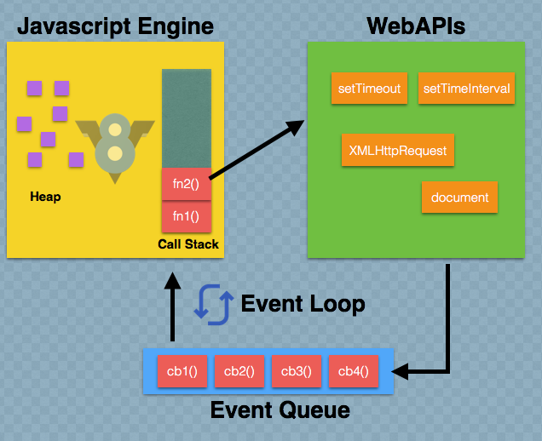

**Node.js:** Just like **WEB-API** in Brower Env Node.js has backend apis inside global which are called **WORKER THREADS** and any **ASYNCHRONOUS tasks** are assigned to worker threads which allows ASYNCHRONOUS programming with SYNCHRONOUS JavaScript and SYNCHRONOUS V8 engine in backend.

**Data Types**

1: Variable datatype is determined at runtime by value assigned.

2: 3 Primitive Types - string, number, boolean.

3: Other Datatypes - undefined, object

4: null is object datatype

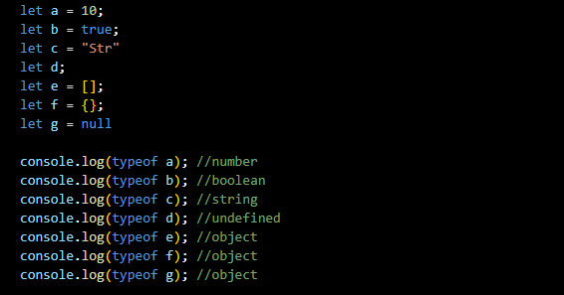

**Variable Scoping**

* If a variable is defined without **var**, **let** or **const** anywhere in .js file. It becomes global variable. We should use **"use strict"** to avoid this.
* if a variable is defined with var. It has scope within the function it is defined in.
* if a variable is defined with let or const. It has scope within the block it is defined in.

**var = Immediate function scope**

**let = Immediate Block scope**

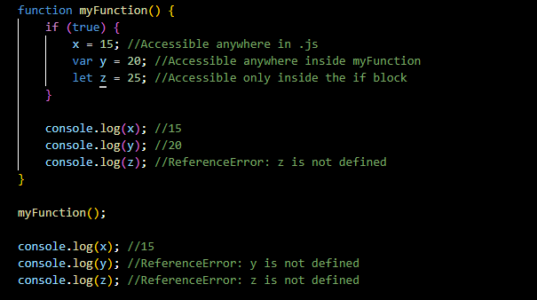

**Hoisting**

* Hoisting Happens only for those that start with words "function" or "var"
* We can avoid hoisting problems by using LET and CONST

**Variables Hoisting**

All variables whether they are assigned with VAR or LET or CONST, all are hoisted. var with undefined value

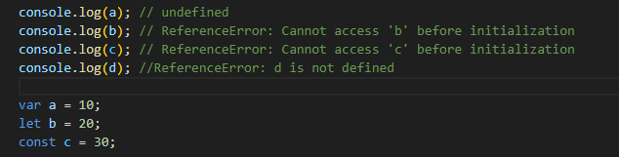

**Functions Hoisting**

* Only the function declarations are hoisted. Any Function expression (LET, CONST) will not be hoisted
* For the Function Expression starting with VAR only the variable will be hoisted with undefined value
* For Example, in case of greet2 and greet3, value will be undefined

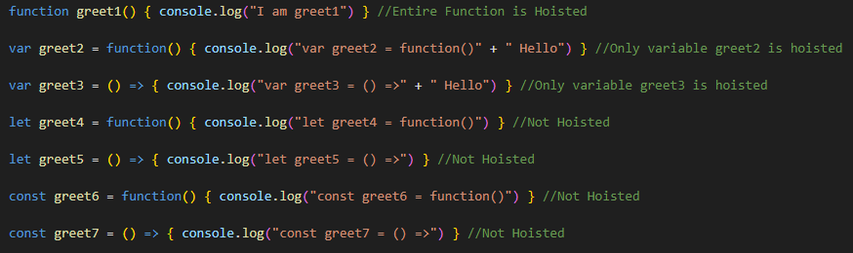

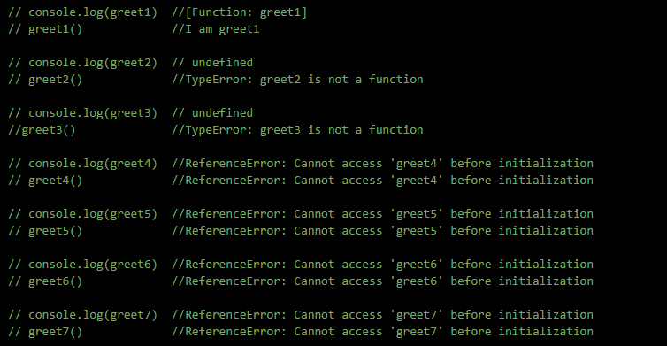

**Execution Context**

* Every function in JS file has its own EXECUTION CONTEXT
* Before even that Every JS File starts with GLOBAL execution Context
* Global Execution Context starts with a global variable WINDOWS (GLOBAL with node) and THIS
* Every Execution context has 2 parts. Creation Phase and Execution Phase
* Creation Phase is where hoisting happens
* Execution Phase then runs code.
* We can avoid hoisting problems by using LET and CONST

In the example below 5 execution contexts are created. Every Execution Context has its own hoisting. For below code following Execution Contexts are created on Call Stack.

getMyName execution context

findMyName execution context

printMyName execution context

Global execution context

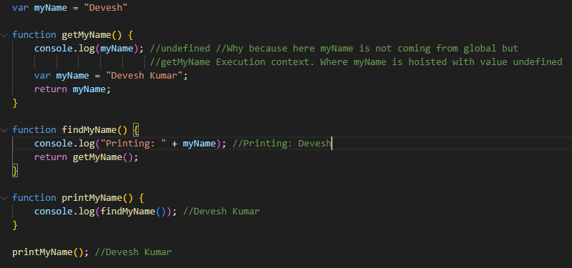

**Lexical Environment or Lexical Scope or Lexical Context**

**Lexical Scoping:** Lexical Scope defines that in which EXECUTION CONTEXT the code/function is written. Based of function’s location, it is determined which variables/data is accessible. In code below

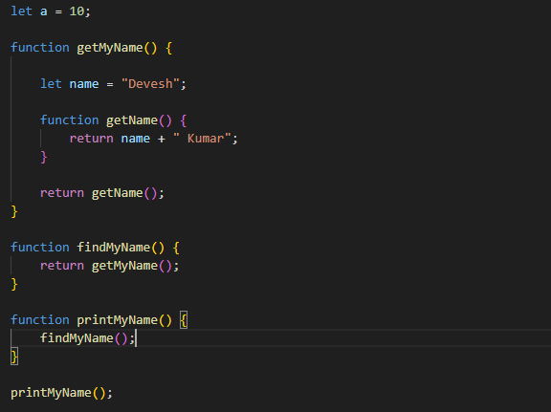

* printMyName() function's lexical scope is Global Execution Context as it's located inside Global & has access to Global Variables
* findMyName() function's lexical scope is Global Execution Context as it's located inside Global & has access to Global Variables
* getMyName() function's lexical scope is Global Execution Context as it's located inside Global & has access to Global Variables
* getName() function's lexical scope is getMyName() Execution Context as it's location is inside getMyName() & has access to Global/variables inside getMyName()

**Dynamic Scoping:** Dynamic Scoping uses the location of the function's invocation to determine which variables/data are available.

**This Keyword**

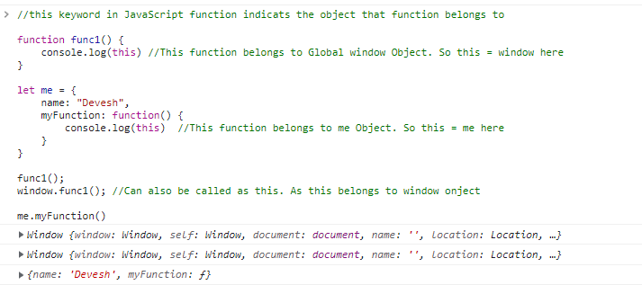

Hello There